

Project Phase 2:

Enterprise Application Implementation Using Odoo

By

Mr. Waris Damkham 6388014

Mr. Thanawath Huayhongthong 6388016

Miss Pattanan Korkiattrakool 6388022

Mr. Naphat Sookjitsumran 6388059

Submitted to  
Assoc. Prof. Dr. Jarernsri Mitrpanont

A Report Submitted in Partial Fulfillment of the Requirements for

ITCS361 Management Information Systems

Faculty of Information and Communication Technology

Mahidol University

2021

**Executive Summary page**

Project phase 2 of ITCS361 Management Information System, successor to Project phase 1, in which we have selected Mazda Motor Corporation as the study company.

This report consists of:

* Business Overview, key business processes, and how ERP system important to the company.
* “Buy & Sell” BPMN diagrams and business process descriptions according to the context of Mazda's business domain.
* Modified “Buy & Sell” BPMN diagrams and business process descriptions based on Odoo strategy with an explanation.
* Odoo screen shots with simulated data to demonstrate of the Creative Modified “Buy & Sell” process flows.
* Reports with useful descriptions for selected company.
* Discussion and conclusion.

The objectives of this project are

* To understand and apply the knowledge of Business Process and ERP system in company.
* To implement Enterprise Application using Odoo.
* To apply to the real business case selected by the student from the Project Phase 1.

**Table of Contents**

Mazda Motor Corporation 4

Mazda company profile 4

Key business process of Mazda 5

SKYACTIV-VEHICLE ARCHITECTURE 9

How ERP system important to Mazda 9

Business Process Modeling Notation 11

Layer 1 – Buy & Sell Process 11

Layer 2 - Buy & Sell Process with extra services 16

Odoo screen shots with simulated data to demonstrate step-by-step of the Creative Modified “Buy & Sell” process flows. 18

A few useful reports for your company and descriptions. 25

Porter’s Five Forces Analysis 25

Porter’s Five Forces consist of 25

Mazda Porter’s Five Forces Analysis 26

Threat of New Entrants 26

Bargaining Power of Suppliers 26

Bargaining Power of Buyers 27

Threat of Substitute Products or Services 27

Rivalry Among Existing Firms 28

Changing the Conventional Communication 29

Mazda’s strategy during the Covid-19 pandemic 29

Further Promoting Brand Value Management 30

Discussion and conclusion on the benefits of ERP system to the company. 31

References 32

Video presentation Link 32

# **Mazda Motor Corporation**

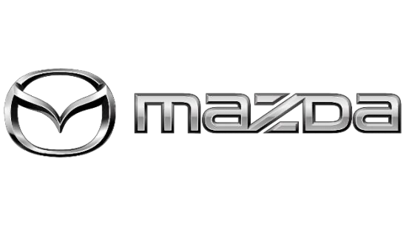

## **Mazda company profile**

Mazda Motor Corporation commonly referred to as simply ‘Mazda’, is a Japanese multinational automotive manufacturer which was founded on January 30, 1920, and Mazda’s headquarters was located in Hiroshima, Japan. The current CEO, President, and Representative Director for Mazda are Akira Marumoto. Mazda’s main goal in business is to manufacture and sell passenger cars along with commercial vehicles, with Mazda’s main products being four-wheeled vehicles, gasoline reciprocating engines, diesel engines, and vehicle automatic and manual transmissions. Mazda's main product line is to manufacture cars and apply specific technologies to vehicles of various models. Along with providing after-sales service to customers in maintenance and health care of various vehicles, as well as giving advice. The main production site in Japan of Mazda, are Hiroshima Plant (Head Office, Ujina), Hofu Plant (Nishinoura, Nakanoseki), and Miyoshi Plant, also Mazda expand its production sites overseas including China, Thailand, Mexico, Vietnam, Malaysia, and Russia which the latter 3 countries do only assembling. Mazda currently has net sales of 2,882.1 billion yen from a capital of 284 million yen, with those sales coming from global product sales of 1,287,501 vehicles in more than 130 countries which extend over 212 branches in Japan and 136 branches overseas.

## **Key business process of Mazda**

* Supply chain process

The supply chain process focuses on the supply chain process and how it could be effective in the supply chain process, as in order to cash, manufacturing, and material supply every step is analyzed so that there could effectively focus on the issues as well as the steps that can be taken in order to improve the process. The focus is on analyzing orders to cash, manufacture, and material supply. Every step needs to be effectively implemented for the effectiveness of the company’s supply chain process so there could be the effectiveness and so that the company could grow and effectively manage the processes.

* Car production

After Mazda receives orders from customers and puts them into production, the first sub-process is building the car body. to produce complex products Industrial processes must be divided into specialized technologies. A special gateway divides the production process containing drive change data into sequential subprocesses. Next is the process of "assembling the car" and the final state of the process is "The car is complete."

* Analyzing

Data analytics is one of the core aspects of organizational stability, strategy, and growth, with a good analysis, will enable better planning to follow. Mazda's analytic plan guides critical business decisions across the enterprise through financial, operational, and strategic analysis.

* Evaluating

This process is all about evaluation and observation. Assessment is the use of information obtained from the analysis stage to assess risks, sales, profits, etc., and most importantly, it is used to assess the risks of an organization. In terms of observation, it is an observation to protect the organization from all risks that may occur.

* The mission statement of Mazda

Every company that offers services to the public wants to encourage and assure customer trust that they are investing in quality vehicles. Automakers and related companies in the industry tend to establish extensive mission statements to serve as promises of reliability to consumers and so is Mazda. The core of Mazda's mission statement is Products that delight and facilitate customers. With the motto "With passion, pride, and speed, we actively communicate with our customers to deliver insightful automotive products and services that exceed their expectations." of Mazda. Mazda builds this mission with excellent and modern technology and performance of the vehicle, and consistent after-sales service, giving customers the confidence to absolutely choose Mazda.

* The vision of Mazda

Mazda's love for cars has made the company want to produce cars that can delight and enrich people's lives. Mazda envisions and strives to produce vehicles that are sustainable and environmentally friendly to the world and society. Moreover, Mazda is ready to face challenges with creativity to create the best cars for customers. Mazda committed to 3 rules to make the best of its customers. Firstly, Brighten people’s lives through car ownership. Secondly, offer cars that are sustainable for the earth and society to more people. Last, embrace challenges and seek to master the Doh (“Way” or “Path”) of creativity. Mazda's Brand Essence is “Celebrate Driving” which is not just about driving performance but also about choosing a Mazda vehicle as a gift to a confident and proud owner. All of this can be explained by Mazda's visionary slogan, which is "To create new value, excite and delight our customers through the best automotive products and services"

* The core values of Mazda

Based on Mazda's outstanding reputation for creating vehicles with sleek, cutting-edge designs and state-of-the-art technologies that make cars of higher efficiency and quality. In addition, Mazda also focuses on developing the mindset of the management team and all employees in order to provide the best service and offer the best products to customers. Mazda's values give further guidance to employees in their daily decision-making and actions. The Mazda Values are "We value integrity, customer focus, creativity, and efficient and nimble actions and respect highly motivated people and team spirit. We positively support environmental matters, safety, and society. Guided by these values, we provide superior rewards to all people associated with Mazda."

* Mazda company’s culture

Mazda has earned the confidence of consumers and customers seeking a car with user- friendly technology and meticulous attention to detail. Mazda's primary objective is to make the driver and passengers feel secure and comfortable. The human-centered design concept addresses optimal body fit for both seats and internal equipment inside the interior space, and another unique aspect is the ‘sky active’ technology. In addition to a fuel-efficient and fun-to- drive engine, the car's body and driving have also been improved by reinforcing the vehicle's construction. Moreover, it is crucial to reduce carbon dioxide emissions from the production line to the final product apart from that, the form and design are contemporary and accessible to all user groups, including the introduction of automobile models in demand in a competitive market in order to develop and give customers value when making selections.

## **SKYACTIV-VEHICLE ARCHITECTURE**

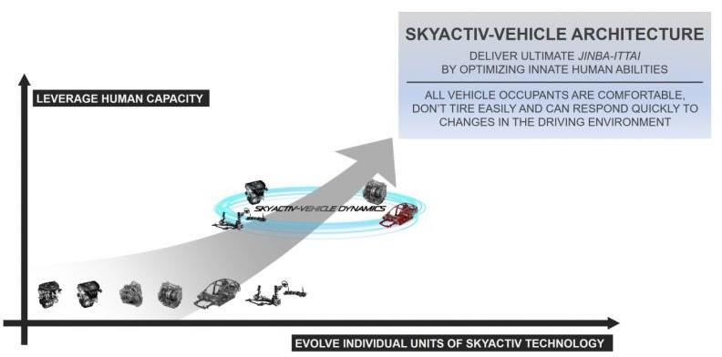

### **How ERP system important to Mazda**

Mazda is one of the world's leading automotive brands. Having the right strategy is essential for planning both now and in the future. For Mazda to be successful, it relies on an information system that helps make planning decisions such as ERP, a business management system that integrates all aspects of the business.

Mazda uses an enterprise application (ERP) to manage information such as productions, sales, and marketing, using technology to control inventory such as purchase orders or auto parts equipment, including various software used in automotive production to be systematic and managed easily and simply. Not only Mazda uses ERP to manage the production of its resources, but also controls and manages the company's finances and human resources, meaning employees and management which is easy to check diverse systems within Mazda's organization. On the other hand, Mazda has implemented an ERP management system to manage their customer's information in sales, order details distribution, and after-sales service provided to Mazda customers, as well as manifold feedback from service providers in each branch around the world. Another important thing is that Mazda uses resource management tools to collect product test statistics such as testing the structural strength of each car model. Since Mazda believes that safety is an international standard in the design and production of vehicles that can be used on the road safely, that makes the testing process even more important. Moreover, with the development of various technologies that help with driving, facilities inside the car must be tested, and collecting various statistical data continues to develop the system to be complete and safe. It can be seen that the enterprise resource management system used by Mazda to enhance the management of information management both inside and outside the organization has affected the progress of the company. Therefore, Mazda has placed great emphasis on the use of internal resource management tools to make it easier to systematically develop and continue to be effective.

# **Business Process Modeling Notation**

## Layer 1 – Buy & Sell Process

Customers can place an order by sending an order request to the sales lanes. Then the sales will send to the customer for confirmation and response back to sales for confirm order and next to check car is available or not. If the car is unavailable it will be cancels.

But if an ordered car is available it sends to Prep lanes in prepare car for delivery sub-process. This process is to check for order that confirm by customer is available for delivery. Next, financial lanes to make a payment.

In financial lanes, it is processed to make a payment by receive data of enter order sub-process for arrange financing. When arranging financing sub-process finished it go to X gateway for check payment status. If financing is available, it goes to parallel gateway for close order and delivery and send message to customer saying a financing is completed. But if financing unavailable it will be cancelled.

The message that sends to customer is about deliver vehicle and temporary registration.

This is an option of finance for customers able to loan money from lender to spend on purchases. Customer should send loan request to lender. Lender will send response to customer after lender accepts a loan request.

## Layer 2 - Buy & Sell Process with extra services

We selected “Offer extra services” strategy because we think that offer extra service can be offer in a variety such as product extra services, customer extra services and membership extra services. In this creative modified “Buy & Sell” BPMN diagram we focus on customer services. Because customer service is important because it helps your business stand out from the competition. This will help keep that customer loyal to the brand, products and services for years to come. But this is only possible if your business puts customer service first, which corresponds to the business domain of Mazda which puts customers first to build the stability of the customer group.

We add customer services into customer pool lanes. When a message sends from finance to customer it keeps into warranty card and member card data. These two are go to customer service process and have two conditions of products to check. In case the total distance traveled is not more than 10,000 km customer can have free maintenance services. But if more than 10,000 km it loses warranty and not have free service for that product. Maintenance services and lose warranty it goes to notify process to notify customer about a time that services are expired and send message to customer.

# **Odoo screen shots with simulated data to demonstrate step-by-step of the Creative Modified “Buy & Sell” process flows.**

First, we have received an order from a customer. We will check in the inventory to see if we have the products or not. ––Go to the inventory to create the product name “All New Mazda 2 Sedan”. You will know that we don’t have the product on hand. So, we need to purchase from the vendor.

Then, go to the purchase module to create the request for quotation.

Go back to the inventory module. In the receipts box it will have 1 to process click that.

Click validate.

We will have five goods available. Consequently, we can deliver product to our customers.

Go to sale module. Then, create a quotation.

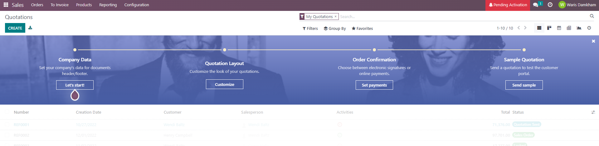

Extra Service

This is an invoice in the sale module.

Go back to the inventory module. It will have 1 to process in the delivery order.

Click validate it.

Then, the product on hand will equal to 0.

In the accounting module, select the journal entries.

Click Validate. We will get the customer invoice.

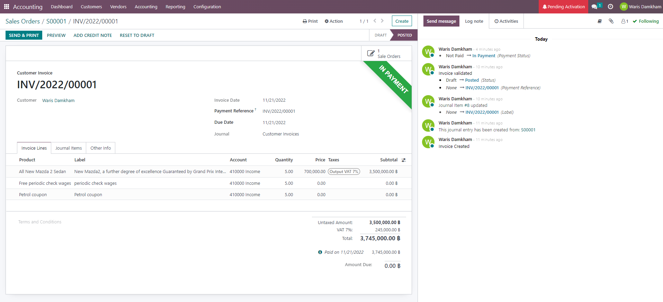

––Select the reporting title by clicking Profit and loss.

# **A few useful reports for your company and descriptions.**

## **Porter’s Five Forces Analysis**

Porter’s Five Forces helps users analyze and identify the main sources of competition in their industry. When users understand the forces affecting an industry, they can surely boost profitability, adjust strategy, and get an advantage over the competition. Using Porter’s Five Forces can help take advantage of a strong position, improve a weak one, and avoid taking risks in the future.

## **Porter’s Five Forces consist of**

1. Threat of New Entrants
2. Bargaining Power of Suppliers
3. Bargaining Power of Buyers
4. Threat of Substitute Products or Services
5. Rivalry Among Existing Firms

## **Mazda Porter’s Five Forces Analysis**

### **Threat of New Entrants**

* In a large industry like Mazda, it is quite difficult to save costs which Mazda operates. This makes it easier for those producing large capacitates to have a cost advantage. It also makes production costlier for new entrants. This makes the threats of new entrants a weaker force.
* Within the industry, enterprises sell distinctive items rather than standard products, demonstrating how significant product differentiation is within the sector. Customers seek out products that are unique. Additionally, there is a big focus on marketing and customer support. Due to all of these factors, the threat of new competitors is a weak force in the market.
* Newcomers can quickly set up their distribution channels and enter the market since they have simple access to distribution networks. It is simple for every new entrant to get its product on the shelves because there are only a few retail establishments that sell the product type. All of these factors, the threat of new competitors is a powerful force in this market.

### **Bargaining Power of Suppliers**

* The suppliers don't represent a significant threat to further integration into Mazda's segment of the market. As a result, suppliers have less power when it comes to negotiating inside the industry.
* Mazda's suppliers rely heavily on business from the industry in which it operates. As a result, the industry's profitability generally highly correlated with that of its suppliers. Hence, these providers must offer fair prices. As a result, suppliers have less power in the industry when it comes to negotiating.
* The vendors are not in competition with others to obtain a competitive advantage. This indicates that there are no alternatives to the goods available other than those offered by the vendors. This means suppliers now have more power in the industry's agreements.

### **Bargaining Power of Buyers**

* Within the industry, the buyers' income is weak. This indicates that consumers are under pressure to make low-priced purchases, which increases their price sensitivity. As a result, consumers' purchasing power becomes a less powerful force in the market.
* Since there is a high level of differentiated products within the industry, customers may not be able to locate other companies that are producing a certain product. Customers' negotiating strength within the industry is weakened by this obstacle to changing.
* In the industry in which Mazda operates, there are many more suppliers than there are companies that produce the products. This means the buyers have a limited number of companies to select from and very little control over pricing. This weakens the buyers' bargaining position inside the industry.

### **Threat of Substitute Products or Services**

* There are not too many products that can be used in place of those made by the company Mazda in its industry. The few accessible alternatives are also produced by low profit-making industries. This indicates that there is no upper limit on the maximum profit that companies in the industry wherein Mazda operates may achieve. Due to all of these factors, the threat of competitive products is much less powerful.
* The severely limited alternatives are of high quality but are significantly more expensive. Comparatively, companies in the industry where Mazda operates sell products at a lower cost while maintaining a sufficient level of quality. As a result, consumers are less likely to move to competitive products. This indicates that the industry is not particularly threatened by substitute items.

### **Rivalry Among Existing Firms**

* Within the industry in which Mazda operates, a significant amount of differentiation exists between products. Because each of the competing businesses' products is unique, it is challenging for them to attract customers from each other. Due to this, industrial competition between established companies is a less powerful force.
* Due to the variety of their strategies, the companies in the industry are all distinct from each other. They thus collide with each other in terms of strategy as a result. This makes competition in the industry among existing companies a powerful force.
* Within the industry in which Mazda operates, a significant amount of differentiation exists among products. Due to the fact that each of the competing companies' products is unique, it is challenging for them to attract customers from other companies. Due to this, industrial rivalry between existing companies is a less powerful force.
* The industry in which Mazda works has substantial fixed expenses. Due to this, companies in the sector operate at maximum capacity. This also implies that these companies will reduce their pricing when prices drop. This makes existing company competition become a more powerful force within the industry.
* The industry in which Mazda operates experiences annual growth and is expected to do so for the coming several years. Positive industry growth suggests that rivals are less inclined to engage in strong competition since they are not competing for the same market share. Due to this, industrial competition among existing companies is a less powerful force.
* There are not too many competitor companies in the market where Mazda operates. The majority of these are also rather large. This implies that businesses in the industry didn't intervene without being observed. Due to this, industrial competition among existing companies is a less powerful force.

## **Changing the Conventional Communication**

     Mazda introduced its trademark anthem, "Zoom-Zoom," in 2002. The slogan has effectively built Mazda's brand image as it is now in combination with sporty product lines. "Zoom-Zoom" is a representation of how Mazda's creativity and innovation consistently provides customers with pleasant and thrilling driving experiences for those who still recognize the sensation of motion as a youth. The brand slogan, however, initially tended to solely serve as a component of the marketing communication plan. Therefore, from the perspective of creating a relationship with the customer, Mazda had to modify its traditional marketing approach in order to incorporate the brand slogan into the day-to-day operations of distributors and dealerships.

## **Mazda’s strategy during the Covid-19 pandemic**

The past Covid-19 outbreak has caused a widespread impact on all industrial business systems as well as the automotive industry. Therefore, Mazda adjusts its business strategy for sustainable growth, increasing brand value and customer experience to adapt to the COVID-19 situation by using the “MAZDA CPO” (Certified Pre-Owned) strategy. Mazda's executives predict that the automotive industry for fiscal 2022 will have cumulative sales of about 820,000 to 850,000 vehicles, and he believes Mazda will sell more than 40,000 vehicles, a 15% increase due to the situation that has improved due to several factors. In the fiscal year 2022, Mazda is preparing to penetrate the used car market by offering customers quality used cars with the new business "MAZDA CPO". The “MAZDA CPO” is an exchange channel under the trading cycle management strategy that customers will benefit the most from being Mazda car owners 'Used Mazda cars' are certified by Mazda Sales (Thailand) and passed a 100-point inspection. MAZDA CPO will increase the residual value of Mazda used cars also enhance Mazda's brand value and increase customer confidence. Currently, MAZDA CPO has opened 9 branches and expects to increase from 18 branches to 38 branches nationwide by 2025.

## **Further Promoting Brand Value Management**

In 2013, Mazda has been promoted in earnest from promoting initiatives to enhance its product and corporate brand value, while negotiating dialogue with customers and other stakeholders which this concept is called "Brand Value Management". Mazda believes in developing its business and enhancing its corporate value by gaining the trust and support of its stakeholders.

# **Discussion and conclusion on the benefits of ERP system to the company.**

Mazda is one of the world's leading automotive brands. ERP is a business management system that integrates all aspects of a business. Mazda uses ERP to manage the production of its resources, and also controls and manages the company's finances and human resources. It can be seen that the enterprise resource management system used by Mazda to enhance the management of information both inside and outside the organization has affected the progress of the company.

# **References**

“Mazda Porter Five Forces Analysis.” *Essay48*, [www.essay48.com/term-paper/13888-Mazda-Porter-Five-Forces.](www.essay48.com/term-paper/13888-Mazda-Porter-Five-Forces.%20)

“MAZDA NEWSROOM｜AT a GLANCE.” *MAZDA NEWSROOM｜AT a GLANCE*, www. [https://newsroom.mazda.com/en/about/at-a-glance/?_ga=2.143211378.655417262.1668962670-1425914763.1668962670.](https://newsroom.mazda.com/en/about/at-a-glance/?_ga=2.143211378.655417262.1668962670-1425914763.1668962670.%20)

# **Video presentation Link**

Link: <https://youtu.be/eM_8MC1I4fo>